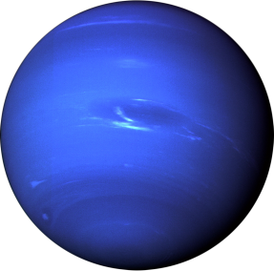
Stage 3: Final unit assessment- Information Report
Due Date: Tuesday 3rd May 2016
Your task was to RESEARCH the key features of the planets of the Solar System and compare how long each takes to orbit the sun.
If you completed your research during library time you should now be at the writing stage.
Instructions:
- Choose 1 planet from your research.
- Write an information report about that planet.
- Publish your work using the cardboard and other paper given to you.
Hand in to Mrs Sharp by the due date.
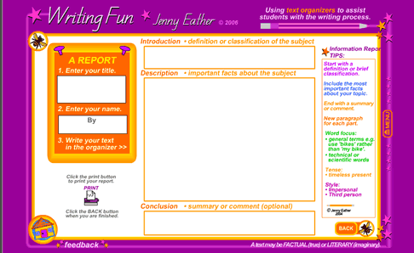
Things to remember
- It must be your own original work.
- Your information report should match your research in your BIC workbook.
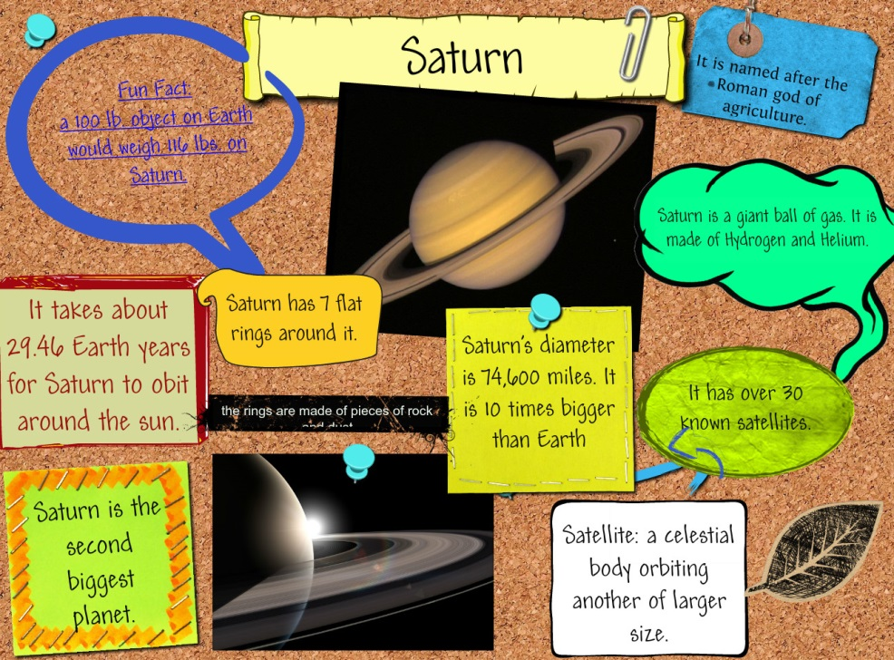
- Use the Busbybic.weebly.com website
- You do not have to print colour pictures. Hand drawn is great!

