Name:
How to Research
Week 1: How does a thermometer work?
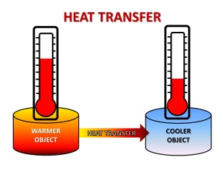
Steps of research:
Step 1: Log onto your portal
Step 2: Type this week’s question into google search
Step 3: Click on “How does a thermometer work- Energy Quest”
Step 4: Read the information
Step 5: Read it again and look for key words.
Step 6: Are there any words you do not understand? How can you locate the meaning?
Words I do not understand
- __________________________________________________________________________
- __________________________________________________________________________
- ___________________________________________________________________________
Step 7: Record some brief dot points of information to later make 3 sentences.

Step 8: Now make your dot points into sentences. Use the question as a sentence starter
A thermometer works because _______________________________________________________ ______________________________________________________________________________________________________________________________________________________________________________________________________________________________________________________
Step 9: Record the website address where you got your information up to the 3rd slash.
________________________________________________________________________

